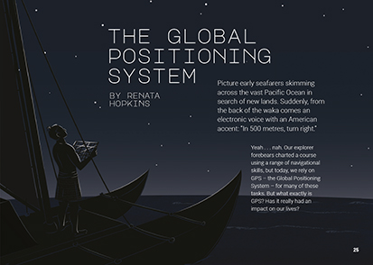

The Literacy Learning Progressions: Meeting the Reading and Writing Demands of the Curriculum describe the literacy-related knowledge, skills, and attitudes that students need to draw on to meet the demands of the curriculum.
Connected
Level 4
2019

The Global Positioning System
by Renata Hopkins
The Learning Progression Frameworks (LPF) describe significant signposts in reading and writing as students develop and apply their literacy knowledge and skills with increasing expertise from school entry to the end of year 10.

Overview
This article explains the Global Positioning System – a technology that we’ve quickly become dependent on. It explains how it works and its benefits, while also prompting students to think critically about the risks of over-reliance.
A Google Slides version of this article including additional digital content is available at www.connected.tki.org.nz

Curriculum contexts

TECHNOLOGY: Nature of Technology: Characteristics of technology  Level 4 – Students will understand how technological development expands human possibilities and how technology draws on knowledge from a wide range of disciplines.  Designing and developing digital outcomes: Progress outcome 2  In authentic contexts and taking account of end-users, students make decisions about creating, manipulating, storing, retrieving, sharing, and testing digital content for a specific purpose, given particular parameters, tools, and techniques. They understand that digital devices impact on humans and society and that both the devices and their impact change over time … | Key technology ideas  - The development of new kinds of technology enables further technological development.  - GPS is a network of satellites orbiting Earth, transmitting radio signals that can be picked up by receivers such as digital devices.  - By combining signals from the satellites, GPS can accurately locate the position of GPS-enabled devices.
MATHEMATICS and STATISTICS: Geometry and Measurement: Position and orientation  Level 4 – Communicate and interpret locations and directions, using compass directions, distances, and grid references. | Key mathematics ideas  - Average speed = distance travelled ÷ time taken.  - Light travels at a constant speed, so we can use the time it has taken to get to a point to calculate the distance it has travelled.  - We can know the location of something if we know its distance from at least three other objects.

ENGLISH: Reading  Level 4 – Ideas: Students will show an increasing understanding of ideas within, across, and beyond texts. | Indicators:  - makes meaning of increasingly complex texts by identifying and understanding main and subsidiary ideas and the links between them  - makes connections by thinking about underlying ideas within and between texts from a range of contexts  - recognises that there may be more than one reading available within a text  - makes and supports inferences from texts with increasing independence.

The New Zealand Curriculum

Meeting the literacy challenges

The main literacy demands of this text lie in interpreting and understanding abstract technical information and vocabulary. While the technological language is supported with explanations, some longer words rely on prior knowledge or contextual clues.  The explanations include some complex sentences with multiple clauses. They are supported by examples and explanations that help make the abstract technological ideas real. Visual support is provided through pictures, diagrams, photographs, and a two-page infographic.  The humour and colloquial tone of the article give appeal to what could otherwise be quite a dry topic. By speaking directly to the reader and by beginning with a familiar context, the writer helps readers to understand the usefulness of GPS and to think about its implications. | The instructional strategies below support students to meet the literacy challenges of this text. For each strategy, there are links to the relevant aspect of The Learning Progression Frameworks (Reading). The signposts on each of these aspects provide detailed illustrations on what to notice as your students develop their literacy knowledge and skills for different purposes in different curriculum areas.  The following strategies will support students to understand, respond to, and think critically about the information and ideas in the text.  You may wish to use shared or guided reading, or a mixture of both approaches, depending on the reading expertise of your students and the background knowledge they bring to the text.  After reading the text, support students to explore the activities outlined in the following pages.

INSTRUCTIONAL STRATEGIES

Finding the main ideas  [LPF Reading: Acquiring and using information and ideas in informational text]  Have the students read the introduction and think, pair, and share their responses to the writer’s questions. Clarify that these are rhetorical questions, which the writer wants us to think about before addressing them in the article. Have the students PREVIEW the text to get a sense of how it moves from an explanation of what GPS is through to looking at its implications. DISCUSS the term “impact” to get the students thinking about the range of possibilities.  An impact is an effect. It might be positive or negative. My television impacts on my life because it’s a great source of entertainment and information. But it can have a negative effect when I watch too much and don’t do other interesting or important things. I wonder what the impacts of GPS might be.  RECORD the students’ ideas, then have them use a PMI chart (plus, minus, interesting) to capture what they learn about the Global Positioning System as they read.  After the reading, return to the writer’s initial questions.  Do you feel that you now understand how GPS works? Turn to a partner – see whether you can explain it. Do you still have questions? How can we help each other so we can all understand?  Take a look at your PMI chart. What did the writer have to say about the impact of GPS on our lives? Overall, would you call the impact positive or negative?  What is in your “interesting” column? Are there things you would like to know more about?  Have the students try the navigational experiment on page 32. Have them write this up as a scientific investigation. DISCUSS and COMPARE their results and consider whether there are messages they would like to convey to other people. | Using visual features for deeper understanding  [LPF Reading: Making sense of text: using knowledge of text structure and features]  EXPLAIN that science and technology texts often use diagrams and infographics to clarify complex or abstract ideas. Have the students work in pairs to interpret the diagrams on page 27 that explain trilateration.  What do the circles show you? What do the labels A, B, C, P, P1, and P2 represent?  Why are three satellites needed to provide an accurate position?  Take turns at summarising the diagram to each other.  How helpful was the diagram in explaining trilateration?  DISCUSS the infographic on pages 28 and 29. MODEL how it works, using the section on clock synchronisation as an example. Then have the students work in pairs to take turns connecting the written text to the symbols and their place in the landscape above. As a group, EVALUATE whether this was a successful way of representing the information and consider whether it would be a useful technique for other kinds of information.  Dealing with unfamiliar vocabulary  [LPF Reading: Making sense of text: vocabulary knowledge]  Have the students create a chart to LIST the topic-specific vocabulary. PROMPT them to notice that the vocabulary belongs to at least two groups: mathematical terms and technological terms. Working in pairs, have the students use information from the text and from their prior knowledge to write definitions of the new terms. Have them use print or online dictionaries to revise and improve their definitions and then exemplify each term, either by writing a sentence or by drawing an image. Pairs of students could critique each other’s charts.

Meeting the literacy challenges

Technological terms What we think this means What we now know it means Example  Mathematical terms What we think this means What we now know it means Example | Note: If you have older dictionaries, students may notice that some words used in the text, such as “software”, don’t appear in them. Other words, such as “digital” do appear, but not with their current meaning. This could be a great opportunity to explore the impact of digital technologies on our language.  Students could use Quizlet to learn more words beginning with the prefix “tri”. This could be a particularly helpful activity for English language learners.

The Learning Progression Frameworks
The Literacy Learning Progressions
Effective Literacy Practice: Years 5–8

Illustrating the key ideas

GPS is a network of satellites orbiting Earth, transmitting radio signals that can be picked up by receivers such as digital devices.  Digital devices impact on humans and society.  By combining signals from the satellites, GPS can accurately locate the position of GPS-enabled devices. | 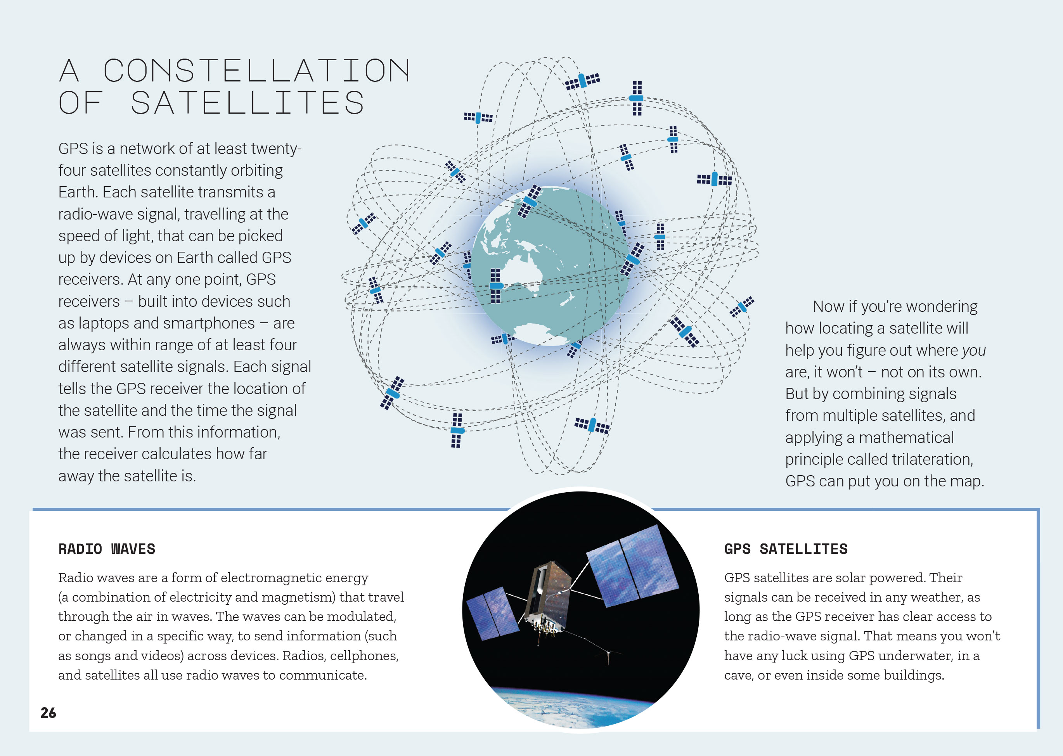  We can know the location of something if we know its distance from at least three other objects.

Learning activities – Exploring technology
and mathematics and statistics

Activity 1 – Trilateration and the geometry of spheres  Have the students reread the section on trilateration. Ask them to discuss in pairs why there is only one intersection point when you introduce a third circle, and then play them the video on trilateration (see resource links below) to check their answers.  Have the students act out how trilateration works. Select a location in the classroom for them to work out where it is. Have one student act as Satellite One and tell them they are 2m from the location. Using a length of string 2m long ask the class where the location could be, i.e. in a circle 2m from that student. Tell the student who is Satellite Two that they are 3m from the location. Satellite Two uses a length of string 3m long to show where the location could be with the class finding that it intersects in two places with Satellite One. Using a student as Satellite Three, tell them they are 2m from the location to identify which of the two possible locations is the correct one.  Give the students graph paper, rulers, and sets of compasses and have them experiment with drawing circles to find a location. Then tell them that every square on the graph paper represents 0.5 seconds. Knowing that, can they work out how far away each of their three satellites is? Prompt the students to explain their reasoning to each other.  Extend the students’ understandings about geometry and its purpose to “measure the Earth”, using the Figure It Out activities, “Where on Earth?” and “Going Global”. Activity 1 of “Going Global” will be particularly useful for those students who are still not quite sure about trilateration. When the students have completed these activities, they could review, amend, and perhaps add to their vocabulary charts.  Tell the students that people often get confused between trilateration and triangulation. Challenge them to create a definition that clarifies this for somebody who doesn’t know the difference. Note that they will have to do further research to do this!  Move on to an investigation of satellites, culminating in the Science Learning Hub activity on using a scale model for satellite orbits. In this activity, students use a scale model of Earth to identify the altitudes of various satellites. They then use a smaller object on a string to model gravity and satellite motion. Through this activity, they will move to a better understanding of the geometry of spheres. Have the students critique the model, identifying how it reflects and does not reflect reality.  Extending the learning  The Figure It Out teacher support materials make the connection between mathematics and culture. They reference the navigation skills of Polynesian explorers who sailed long stretches of ocean using information from the stars and other environmental clues to identify their location and where they were going. | The following activities and suggestions are designed as a guide for supporting students to explore and extend their content knowledge across the learning areas. Adapt these activities to support your students’ interests and learning needs.  Have the students investigate the knowledge, skills, and technology required for traditional Polynesian navigation and compare it with using GPS to navigate “by satellite”. “The Long Pause” in Connected 2019, Level 3, offers support for such an investigation.  Activity 2 – Putting GPS to work  Review the multiple uses of GPS that are introduced in the infographic on pages 28 and 29. List these and discuss what the students already know about each example and what they would like to know.  Have the students read the Radio New Zealand item about New Zealand’s recent investment in a Satellite-Based Augmentation System (SBAS), intended to greatly enhance the accuracy of GPS.  Does this prompt any more questions for you? Do you have any new ideas about how GPS might help us in the future?  Work with the students to co-design a framework that will guide them to investigate an application of GPS that particularly interests them. Make sure their framework incorporates:  - a description of how their chosen example actually works  - an explanation of the features that make this particular application fit for purpose  - an explanation of what makes this use of GPS a “game changer” for the people who will use it  - a consideration of potential pitfalls and how to avoid them  - an educated guess about where this technology is likely to go next.  Have the students share what they have learned, perhaps in an annotated version of the infographic on pages 28–29 of the article. As they do this, discuss how much of what they have recorded is fact and how much is opinion, based on limited information.  Review page 31 of the article, “What happens if GPS fails?” Return to a consideration of the “bigger picture” regarding the pluses and minuses of GPS and what we need to do to ensure that we use it wisely and with minimal risk.

Activity 3 – Map my Waahi: Discovering our shared heritage  “Map my Waahi” is a LEARNZ field trip that was undertaken in 2019. Its purpose was to support students and teachers to explore the diverse heritage of their classrooms. Many of the resources created through this field trip are now available on the LEARNZ site.  They include links to free tools students can use to create interactive maps that tell their stories through photos, videos, and texts. A cross-curricular experience such as this gives meaning and purpose to students’ engagement with GPS and GIS (Geographic Information Systems). | The content supports inquiry into:  - our identity and sense of place  - traditional European paper maps  - modern digital maps  - 3-D and layers for maps  - free online tools for making and viewing your own digital maps (for example, Google Earth, Tour Builder, Maps, Street View, Expeditions, Voyager, My Maps)  - mapping projects (for example, around conservation or heritage themes)  - primary and secondary sources of information (for example, interviews, photos)  - Māori sense of place through waka, maunga, awa, and rohe  - genealogy, whakapapa, and digital pepeha.

RESOURCE LINKS

Connected  “The Long Pause”, Connected 2019, Level 3, Shifting Views  Figure It Out  Level 4: Technology transformations:  - Going global: https://nzmaths.co.nz/resource/going-global  - Where on Earth? https://nzmaths.co.nz/resource/where-earth-0  - Teacher support material: https://nzmaths.co.nz/sites/default/files/FIO/33810.pdf  Science Learning Hub  The star compass – kāpehu whetū: https://www.sciencelearn.org.nz/resources/622-the-star-compass-kapehu-whetu  Global positioning system (GPS): https://www.sciencelearn.org.nz/resources/1609-global-positioning-system-gps  GPS development in context (timeline): https://www.sciencelearn.org.nz/resources/1618-the-development-of-electrical-sensors-timeline  Satellites: https://www.sciencelearn.org.nz/search?term=satellites  Sensors in satellites: https://www.sciencelearn.org.nz/resources/1604-satellite-sensing  Scale model for satellite orbits: https://www.sciencelearn.org.nz/resources/291-scale-model-for-satellite-orbits  GEO awesomeness  What would happen if GPS failed? http://geoawesomeness.com/what-would-happen-if-gps-failed/  Who invented the GPS? People behind the global positioning system: http://geoawesomeness.com/who-invented-the-gps/ | Other sources  YouTube: How GPS works? Trilateration explained: https://www.youtube.com/watch?v=4O3ZVHVFhes  Land Information New Zealand: Australasian SBAS trial: https://www.linz.govt.nz/data/geodetic-services/australasian-sbas-trial  +plus magazine: The central place of GPS in our lives: https://plus.maths.org/content/recognising-place-gps-has-our-lives  EarthSky look up: It’s a satellite! https://earthsky.org/space/how-to-see-satellites-your-night-sky  LEARNZ Map my Waahi: http://www.learnz.org.nz/mapping183  LEARNZ GPS and GIS Technology: http://learnz.org.nz/highcountry152/gps-and-gis-technology  Radio New Zealand: GPS improvement: Funding will allow pinpoint accuracy: https://www.rnz.co.nz/news/national/392738/gps-improvement-funding-will-allow-pinpoint-accuracy  GISGeograph: Trilateration vs triangulation: https://gisgeography.com/trilateration-triangulation-gps/  How stuff works: How GPS receivers work: https://electronics.howstuffworks.com/gadgets/travel/gps1.htm  New Yorker: What would happen if GPS failed? https://www.newyorker.com/tech/annals-of-technology/what-would-happen-if-gps-failed  NPR: The GPS: A fatally misleading travel companion: https://www.npr.org/2011/07/26/137646147/the-gps-a-fatally-misleading-travel-companion  Quizlet: https://quizlet.com/4230929/prefix-tri-word-list-flash-cards/

